Using the Computed Results

Current Compute Specifications
Job Name | Program | Options | Database Size | Database Description
ACLAME_HMM | hmmpfam | -E 0.001 | 2247 | viral MGEs, version 2.12
ACLAME_PEP | blastp | -b 50 -e -5 | 96213 | viral MGEs, version 2.12
ALLGROUP_PEP | blastp | -b 50 -e -5 | 5429190 | nr peptide set from public dbs, May-09
CDD_RPS | rpsblast | -b 50 -e -3 | 25927 | conserved domain profiles, from NCBI, Jun-09
ENV_NR | blastp | -b 50 -e -3 | 6028192 | nr MG peptide set from NCBI, Jun-09
ENV_NT | tblastn | -b 50 -e -3 | ~18173178 | MG nucleotides from NCBI, Jun-09
FRAG_HMM | hmmpfam | -E 0.001 | unknown | fragment hmms from PFAM/TIGRFAM
PEPSTATS | pepstats |  | n/a | calculation of mw and isoelectric pt
PFAM/TIGRFAM_HMM | hmmpfam | -E 0.001 | unknown | protein families
PRIAM | priam |  | unknown | genome-oriented profiles, Jun-05 (EC# assignment)
PRIAM_GENE_RPS | blastp | -e -10 | 3869 | gene-oriented profiles, Nov-08 (EC# assignment)
SANGER_PEP | blastp | -b 50 -e -5 | 68425 | various small sanger MGs
SIGNALP | signalp | -t gram- -trunc 70 | n/a | signal peptide cleavage sites
TMHMM | tmhmm |  | n/a | transmembrane helices

Compute Database ERD
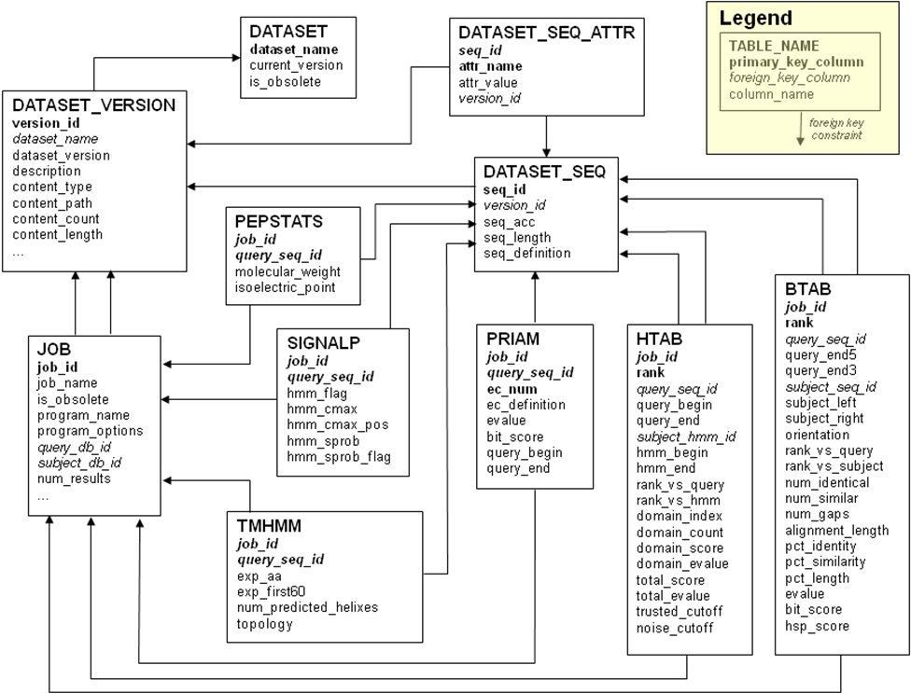

Compute Result Views
COMPUTE_BTAB blast results and sequence details
Pos | Column Name | Datatype | Comment
0 | job_name | text | name of job, e.g. CDD_RPS
1 | is_obsolete | boolean | 1=obsolete result, 0=current result
2 | query_db_id | integer | fk to DATASET_VERSION
3 | subject_db_id | integer | fk to DATASET_VERSION
4 | job_id | integer | internal VICS id for job
5 | rank | integer | overall hsp rank (by evalue, bit_score)
6 | rank_vs_subject | integer | query seq ranked by best hsp against subject
7 | rank_vs_query | integer | subject seq ranked by best hsp against query
8 | subject_seq_id | text | fk to DATASET_SEQ
9 | subject_left | integer | left edge of alignment on subject
10 | subject_right | integer | right edge of alignment on subject
11 | subject_frame | integer | -3, -2, -1, 1, 2, 3
12 | orientation | integer | orientation of query to subject, 1=forward, -1=reverse
13 | query_seq_id | text | fk to DATASET_SEQ
14 | query_end5 | integer | 5’ edge of alignment on query
15 | query_end3 | integer | 3’ edge of alignment on query
16 | query_frame | integer | -3, -2, -1, 1, 2, 3
17 | num_identical | integer | number of identical bases in alignment
18 | num_similar | integer | number of similar bases in alignment
19 | num_gaps | integer | number of gaps in alignment
20 | alignment_length | integer | length of alignment string (including gaps)
21 | pct_identity | float | num_identical divided by averaged aligned lengths of query and subject
22 | pct_similarity | float | num_similar divided by averaged aligned lengths of query and subject
23 | pct_length | float | greatest of %query covered and %subject covered
24 | hsp_score | float | as calculated by blast
25 | bit_score | float | as calculated by blast
26 | evalue | float | as calculated by blast
27 | pvalue | float | not currently used (set to -1)
28 | subject_id | text | id of subject sequence
29 | subject_definition | text | defline of subject sequence
30 | subject_length | integer | length of subject_ equence
31 | query_id | text | id of query sequence
32 | query_definition | text | defline of query sequence
33 | query_length | integer | length of query sequence

COMPUTE_HTAB hmmer results, and hmm and sequence details
Pos | Column Name | Datatype | Comment
0 | job_name | text | name of job, e.g. ACLAME_HMM
1 | is_obsolete | boolean | 1=obsolete result, 0=current result
2 | query_db_id | integer | fk to DATASET_VERSION
3 | subject_db_id | integer | fk to DATASET_VERSION
4 | job_id | integer | internal VICS id for job
5 | rank | integer | overall rank (based on total_evalue, total_score, domain_evalue, and domain_score)
6 | rank_vs_hmm | integer | rank of query sequence vs hmm
7 | rank_vs_query | integer | rank of hmm vs query sequence
8 | subject_hmm_id | integer | fk to DATASET_SEQ
9 | query_seq_id | integer | fk to DATASET_SEQ
10 | hmm_begin | integer | start of match on hmm
11 | hmm_end | integer | end of match on hmm
12 | query_begin | integer | start of match on query sequence
13 | query_end | integer | end of match on query sequence
14 | domain_score | float | score for matched domain
15 | total_score | float | score for entire match
16 | domain_index | integer | domain matched
17 | domain_count | integer | number of domains in hmm
18 | trusted_cutoff | float | scores above trusted are probably meaningful
19 | noise_cutoff | float | scores above noise are possibly meaningful
20 | total_evalue | float | evalue for entire match
21 | domain_evalue | float | evalue for matched domain
22 | hmm_acc | text | id of hmm
23 | hmm_description | text | description of hmm
24 | hmm_len | integer | length hmm
25 | query_id | text | id of query sequence
26 | query_definition | text | defline of query sequence
27 | query_length | integer | length of query sequence
Other Views: COMPUTE_PEPSTATS, COMPUTE_PRIAM, COMPUTE_SIGNALP, and COMPUTE_TMHMM.

Dumping Database Results to Disk

$ echo ".headers on
> .mode tabs
> select query_id, subject_id, evalue, pct_identity, pct_length, rank, rank_vs_query, rank_vs_subject
> from compute_btab
> where job_name='ACLAME_PEP' and is_obsolete=0 and rank_vs_query<=5;" | sqlite3 v0.2_sanger.db > aclame_pep.tsv

$ head -n 5 aclame_pep.tsv
query_id subject_id evalue pct_identity pct_length rank rank_vs_query rank_vs_subject
JCVI_PEP_1113088370064 protein:vir:7086 0 99.0 92.8 1 1 1
JCVI_PEP_1113088370064 protein:vir:103659 0 98.7 92.8 2 2 1
JCVI_PEP_1113087331503 protein:plasmid:158817 1.05771e-160 99.2 100 3 1 1
JCVI_PEP_1113087331503 protein:plasmid:14637 1.05771e-160 99.2 100 4 2 1

